

**Individual Assignment Cover Sheet**

*You must keep a photocopy or electronic copy of your assignment.*

|  |  |  |  |  |
| --- | --- | --- | --- | --- |
| Unit name: | Front-end Web Design | | | |
| Unit code: | 11056 | | | |
| Semester: | 1 | | Year: | 2019 |
| Tutor’s Name: | Riley Post | | | |
| Tutorial Day and Time: | Tuesday 8:30am | | | |
| Assignment Name/Number: | | Assignment 3 | | |
| Case Study Name and Number: | | Front-end Website | | |

**I declare that this assignment is solely my own work, except where due acknowledgements are made. I acknowledge that the assessor of this assignment may provide a copy of this assignment to another member of the University, and/or to a plagiarism checking service whilst assessing this assignment. I have read and understood the University Policies in respect of Student Academic Honesty.**

|  |  |  |  |  |  |  |  |  |
| --- | --- | --- | --- | --- | --- | --- | --- | --- |
| Student ID: | u | 3 | 1 | 6 | 1 | 7 | 3 | 4 |

Signed: ______N.Villiers______________________Date:_________14/05/2019__________

Responsive web-site rationale

Including accessibility audit

Contents

Rationale 2

Background 2

Evolution of the design 2

Paper wireframe 1 2

Paper wireframe 2 3

Adobe XD digital wireframes 4

Final build 5

Design process 7

Challenges faced 8

Solutions to challenges 8

Site influence or inspiration 9

Research performed 12

Color schemes 12

Fonts 13

Accessibility issues or usability issues 14

How were they resolved 15

Accessibility Audit 16

Importance and context of accessibility 21

Summary of main accessibility issues within the site 21

Explanation of main accessibility issues 22

Summary 23

# Rationale

## Background

For this assignment, I have been required to create a website which demonstrates the skills, which I have acquired, throughout the duration of the whole Front-End web Design course. I am required to show that I am able to utilise the skills which I have developed from modules 1, 2 and 3. The requirements of this assignment are that I construct a web site that is responsive, accessible and usable, as well as creating a Rationale and performing an accessibility audit.

## Evolution of the design

The very first part of designing the website, was when I created wireframes to show the basic layout and the responsive transitions used in the mobile, tablet and desktop viewports. You can see these below.

### Paper wireframe 1

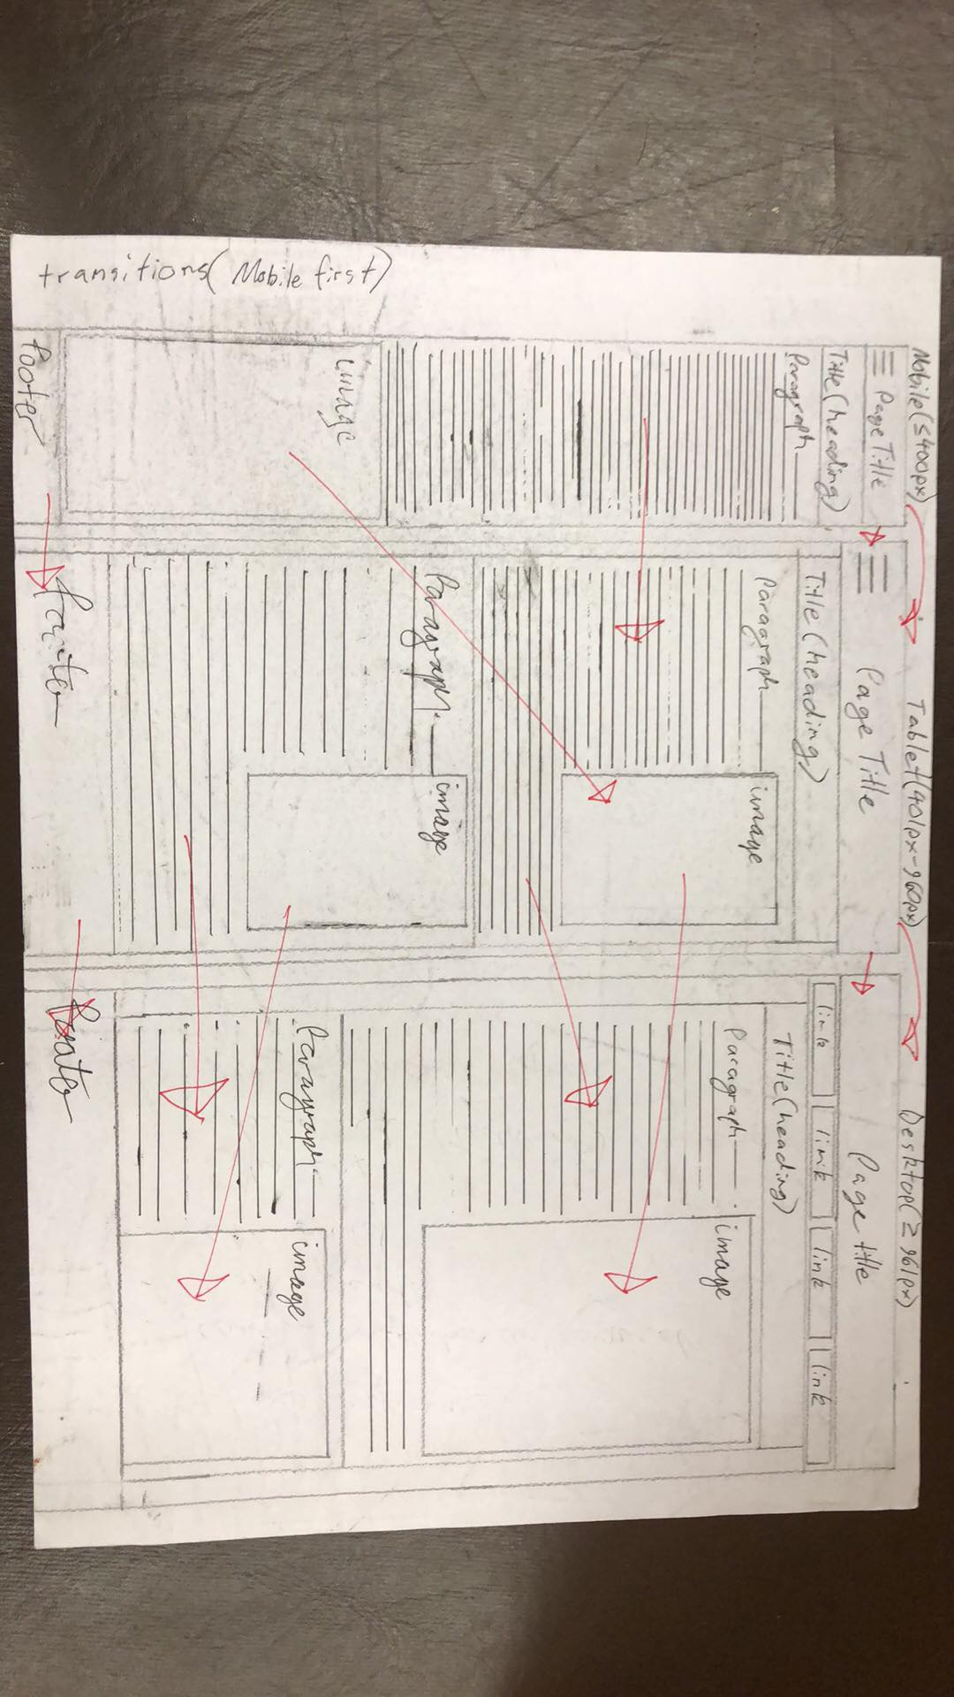

You can see from this wireframe that all of the elements have been maintained, but somewhat rearranged when transitioning from the mobile to the tablet view, and from the tablet view to the desktop. I have used a mobile first responsive design, which means that the default CSS selectors are relevant to the mobile sized viewport and that when a tablet or desktop sized display is utilised, their own CSS selectors are used, using media queries. This was my original wireframe which I drew. I later decided that it was not ideal to have a single column layout and so began to research some other responsive layouts, which could rearrange the content in different viewports. I decided, after looking at multiple other responsive websites, that it would be better to use a design which uses a three-column layout, as you can see in the next wireframe, which I have drawn. You will notice that in the mobile viewport site, that there is a single column, where every section is displayed under the previous one. When you look at the tablet sized viewport, you will notice that the carousel takes 100% of the width of the body, but paragraph 1, 2, 3 and 4 are only 50% of the width of the page body, so that they can be displayed in two columns, next to each other. Finally, the footer is consistently 100% width throughout all three viewports.

In the desktop viewport site, you will notice that a three colunmn approach has been implemented. In this viewport, the content has been rearranged, so that paragraph sections are all above the carousel section. In both the mobile and tablet viewports you can see that a “hamburger menu” has been used alongside the Norfolk Island Logo, which are both nested within the “<nav>” section. In the desktop viewport however, it was drawn so that logo is to the left of four menu items, which would include the link’s text and an image.

I have drawn arrows on the page in red pen, to show how each section transitions when the viewport is changed. You will note that there is a dotted line shown toward the bottom of the wireframe, this is to indicate that some content has not been shown, so that the layout of the page can be shown within the confines of the page. This is called “below the line”.

### Paper wireframe 2

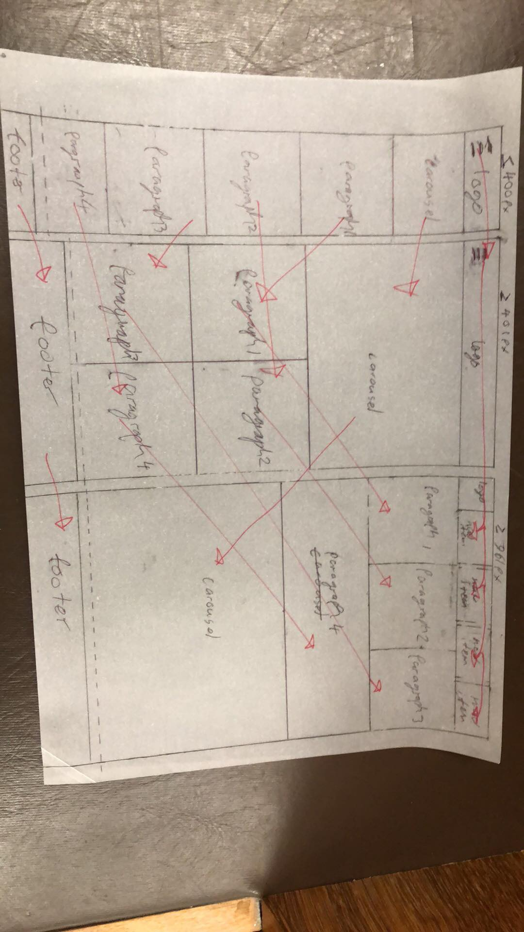

### Adobe XD digital wireframes

After these paper wireframes were drawn, I recreated these digitally using “Adobe XD”. These can be seen on the following page. You will note that these follow the same basic layout, but with color and more styling apparent. You will likely note also that the logo on the desktop was moved to the center, to be in bewteen the menu links, rather than being to the left of them.

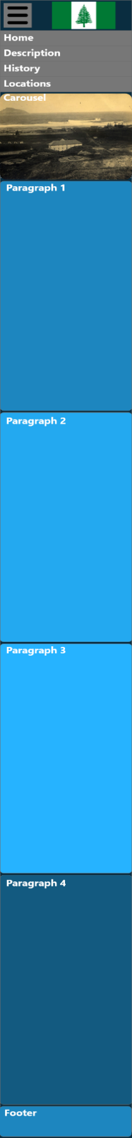 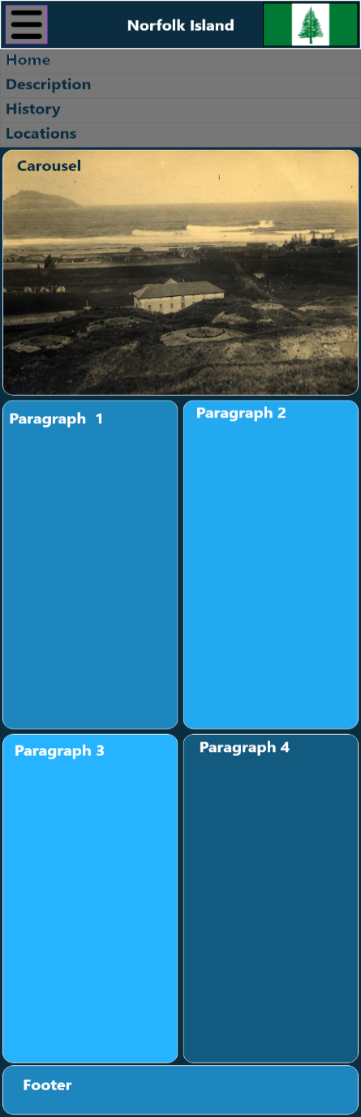 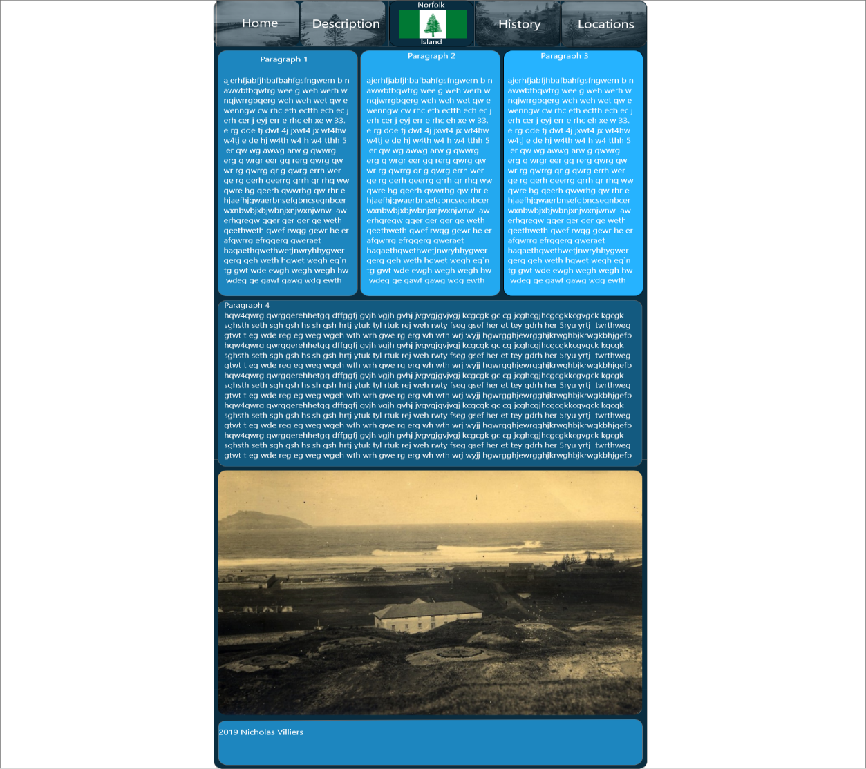

### Final build

After these wireframes were created, I proceeded to build the website, but in this process, the design had changed yet again. After testing the website for accessibility, useability, reponsiveness and overall aesthetcis, I finished with a design which looks like the screenshot below. The final design has some resemblence still, to both the paper wireframes and the Adobe XD ones, but with a few changes. Nonetheless, the layout anmd responsive transitions have remained. Due to the nature of the images relevant to the website, where they have widely varying aspect ratios and resolutions, I have decided against using a carousel and have instead, replaced this section with an additional “feature”, which consist of images and text, with the image being 100% of width of the page. This being the case, there now exists 5 “feature” sections in the layout, instead of 4, as was originally planned. You can see the desktop view, driectly below. You will note that I have decided to include links to social media in the top right corner of the navigation menu.

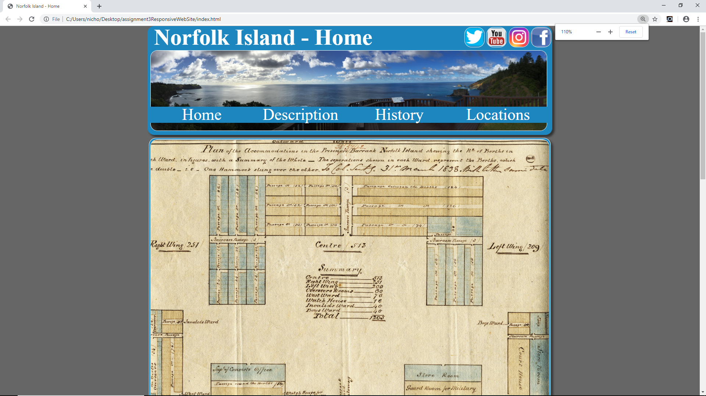

Below you can see both the final tablet view of the website as well as the mobile, with the hamburger menu replacing the desktop naviagtion menu. You can see that the image on the left is of the mobile view and has a single column layout, whilst the one on the right is the tablet view and has a two column layout. You will notice that the social media links have been omitted. This is to prevent too much information being presented on a smaller screen and defeating the purpose of having a reponsive design. The social media links have only been included for display on the desktop view, where screen space is less scarce. I have shown below how the website appears in the mobile, tablet and desktop view.

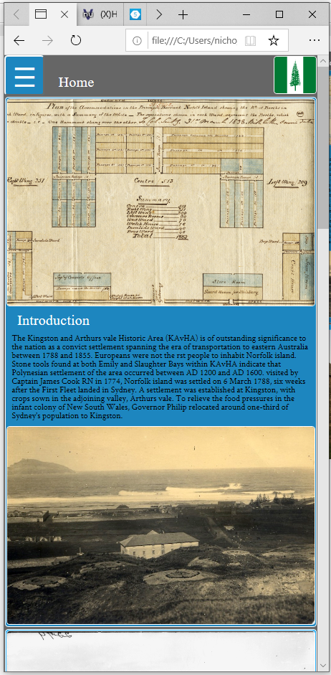 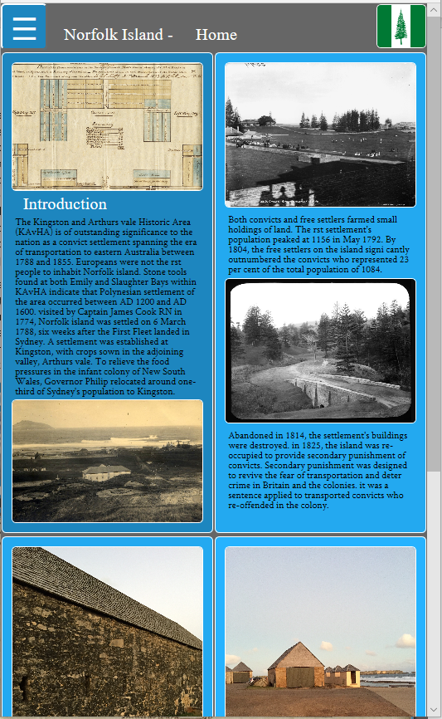

## Design process

As mentioned above, the design process involved creating multiple wireframes, to be used to base my responsive layout upon and also the transitions between different layouts, dependant on the viewport. After these paper wireframes were created, I sought advice from Riley, my tutor, before progressing further. He suggested things like considering a slideshow or carousel, setting scroll speed, using a CSS grid, using a flexbox, using Adobe XD to create some digital wireframes, considering more creative or contemporary navigation menu options, finding alternate fonts, alternating the layout of images nested within paragraphs, and determining the placement of content in which sections. Taking on board this information, I proceeded to create yet another paper wireframe which addressed these issues, where relevant. After I was happy with my new wireframe and the layout, I continue to get set up in Adobe XD, and begun building some digital wireframes. You can see below an image which shows the three digital wireframes I created compared side-by-side. You can see that I have attached labels at the bottom of each view to show the calculated pixel area of each view. The number of pixels used by each design, doesn’t differ too drastically, which I believe shows that the screen space has been used fairly efficiently. You can see that most of the major content is still included, so that the user may still enjoy the functionality of the website, without too much compromise.

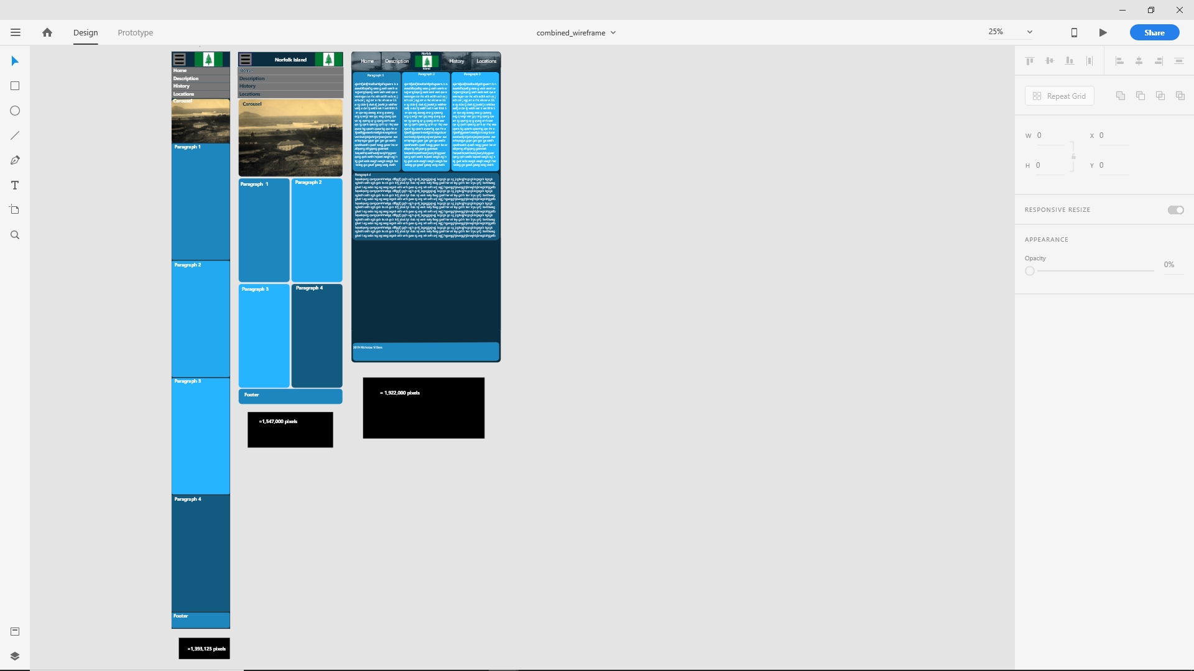

### Building the Website

After I had planned out the layout and design of thee website, I begun to create the website in “Brackets”. I began by creating on basic HTML page and then adding the sections outlined in the wireframe. At this point the sections did not contain any content but were used to merely set the appearance of the website.

I then started to code the navigation menu, which proved to be difficult. I followed a basic unordered list style navigation, as was taught in the course modules.

After this I begun to create the stylesheet, media queries and properties of the elements in different viewports. The page now had a basic structure and looked somewhat like I had planned, in each viewport size.

The next stage was to add all of the paragraphs, headings, and images. The website now contained all of the content which it needed, and I began to tweak the stylesheets to achieve the desired looks and responsiveness.

After this, I performed usability and accessibility testing to ensure compliance, and some changes had to be made, which ultimately changed the overall look of the website somewhat.

## Challenges faced

As has been mentioned, there were some minor issued faced where the layout has been changed slightly, after the initial planning and drawing the wireframes. This can primarily be attributed to accessibility issues, which have been explored further later in this document.

Apart from this I had experienced some difficulty when implementing the two separate navigation menus which the site uses. In the desktop view, the desktop menu is display, which is significantly larger than the mobile/tablet view menu. The tablet/mobile view menu is a “hamburger menu”, which means that when it is not expanded, all that is visible is a symbol which has 3 small parallel lines on a button. This button is used to expand the hamburger menu, so that it becomes visible and usable. This is very helpful in reducing the amount of space that is used, in the mobile and tablet responsive designs.

## Solutions to challenges

To combat accessibility issues, which were mainly based around contrast ratios, and missing headings, I performed accessibility testing and reconfigured the colours used in both the fonts and the background colours of the sections, to ensure that they met the accessibility standard of a 4.5:1 contrast ratio. The tool I used to do this can be found at <https://webaim.org/resources/contrastchecker/>. To combat the issue of headings missing I simply added <h2> headings at the beginning of each new section, so that when using a screen reader or other assistive technologies it is easier to navigate the site. Without headings this type of navigation would prove very difficult.

To successfully implement both the desktop and the laptop/mobile navigation menus, I eventually decided it was best to maintain both menus within the layout, but with only one visible at any given time. The way in which I achieved this, was by creating two menus with two classes, one being “class=”DESKTOP”, the other being “class=” LPTPMBL”. When the website is displayed on a display which is 1000 pixels or less, in width, the “LPTMBL” navigation menu becomes visible and when the display is more than 1000 pixels, in width, the “DESKTOP” navigation menu becomes visible. Because I have used a mobile first design, the “LPTMBL” navigation menu is visible by default and the “DESKTOP” navigation menu is set to be hidden. Both navigation menus coexist on the website, however only one is visible at any given time.

## Site influence or inspiration

As part of the process of developing a responsive website, I have researched several different websites which have made use of responsive design.

I found the following website and have decided to use similar styling with my website, as it is responsive and uses a combination of images and other contents as my website will. It also makes use of a hamburger menu, similar to mine. <https://www.totaste.co/>

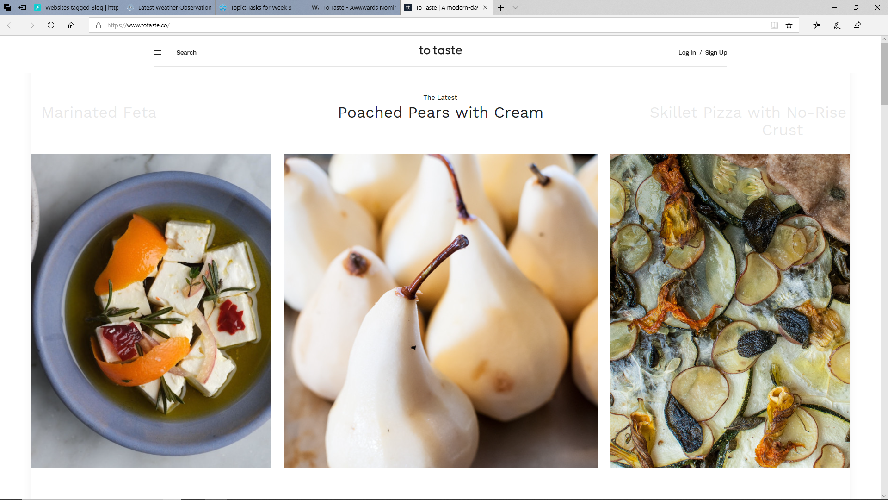

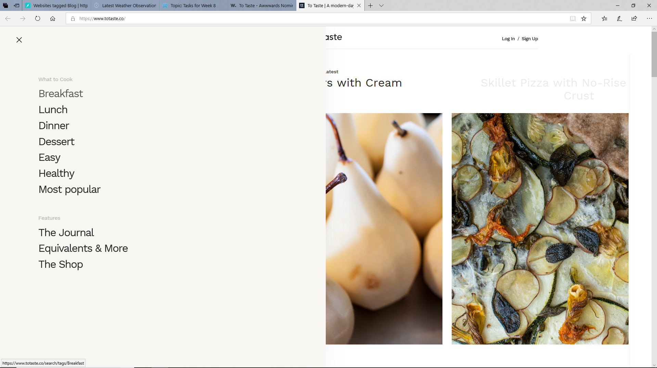

### Second site for inspiration

It was suggested by Riley in the week 9 tutorial, that I seek inspiration for a more creative nav menu, and so I began to research some alternative methods for navigation menus. The sites I look at with these are depicted below. I particularly liked the website listed in the link below called” Plug and play” and have decided to try and create something similar wherein there is a “carousel” at the top and the menu appears directly below this, but with the acceptation that this is just one single image rather than an entire carousel.

<https://www.sitepoint.com/20-standout-navigation-menu-designs/>

The website appears like this image here.

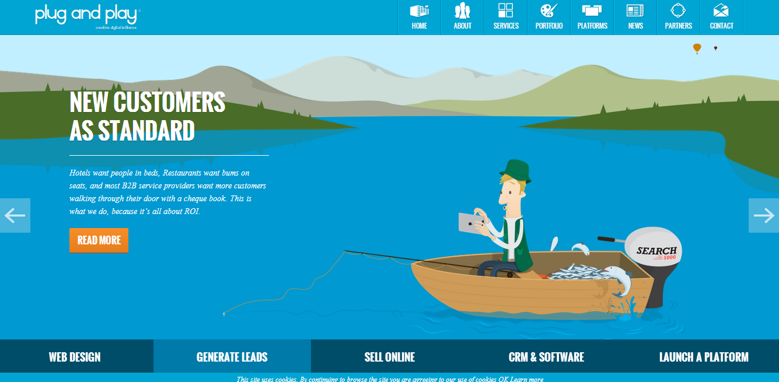

I have used the main image in the navigation area with social media links above it and the main page links below it, similar to what was achieved with he “plug and play” website.

### Third site for inspiration

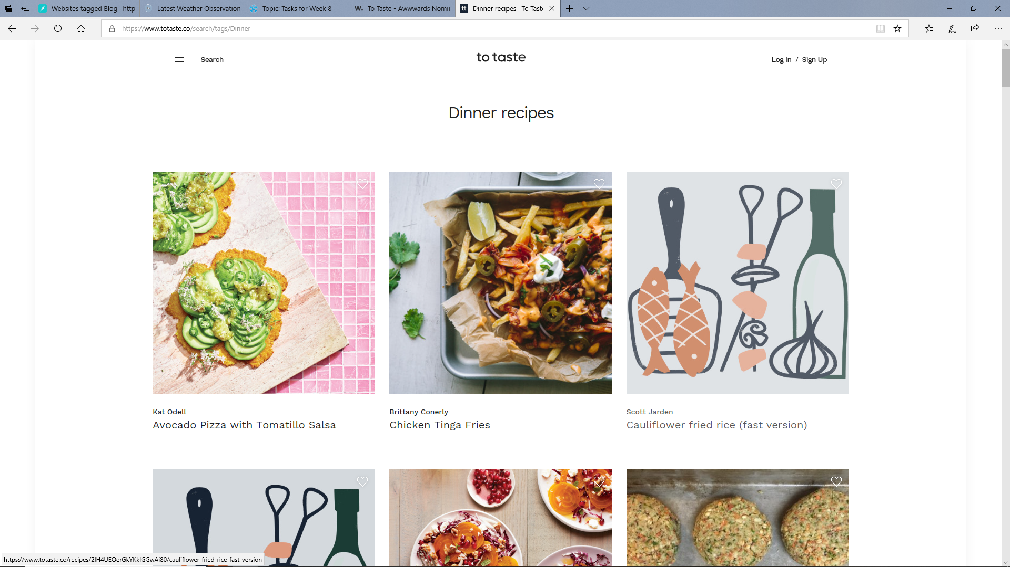

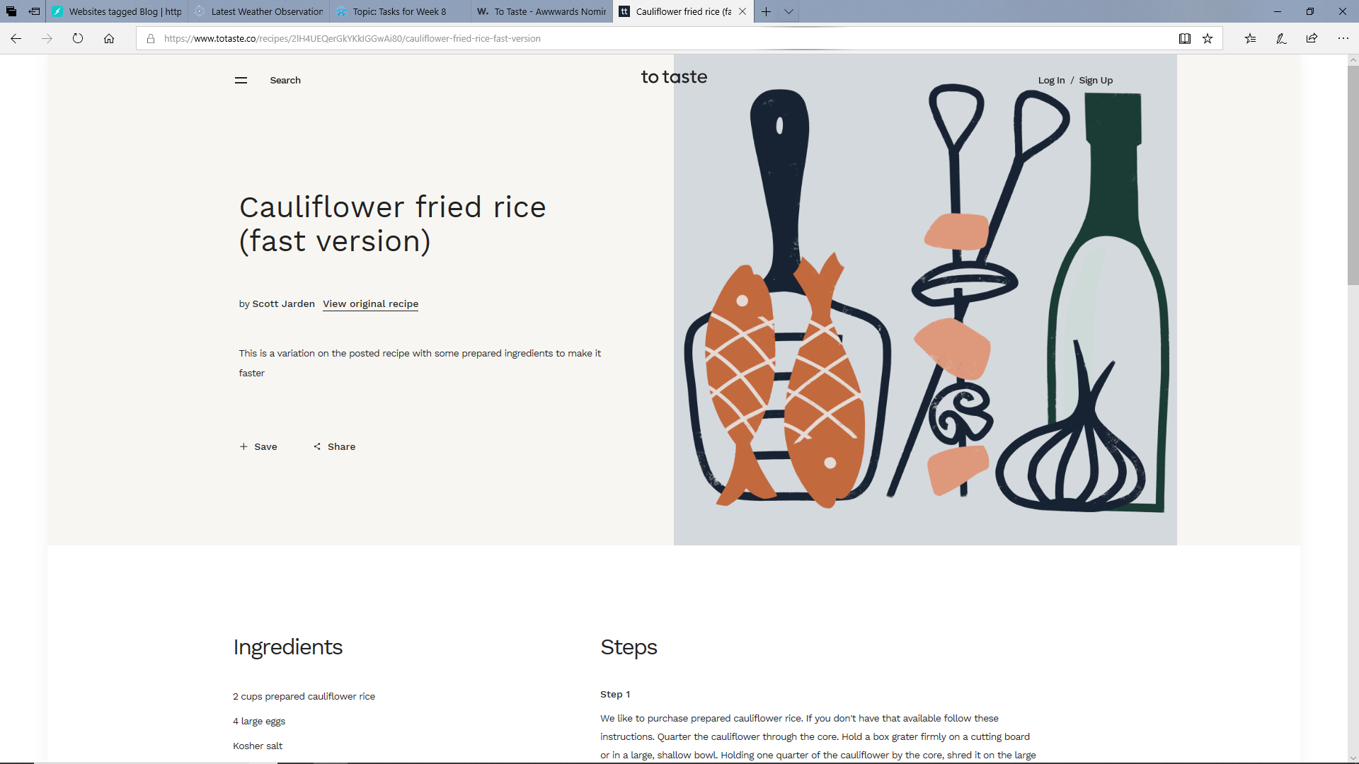

The design featured here (to taste), makes use of a hamburger menu, much like mine does, however with the exception that it is use across all 3 viewport widths, whereas mine is only used on the tablet and mobile sized viewport widths. This website also makes use of a three-column design which reduces to two columns, and then to one column, as the viewport width reduces. In that way, this website behaves similarly to that which I have created.

In the end I have decided on a design which takes aspects of each of these three sites researched and combines them. I have used the column layout found in the first website, the desktop navigation layout in the second website and the hamburger menu layout found in the third website. I have concatenated these designs into one design which achieves the aesthetics and functionality which I had wished to achieve.

## Research performed

### Colour schemes

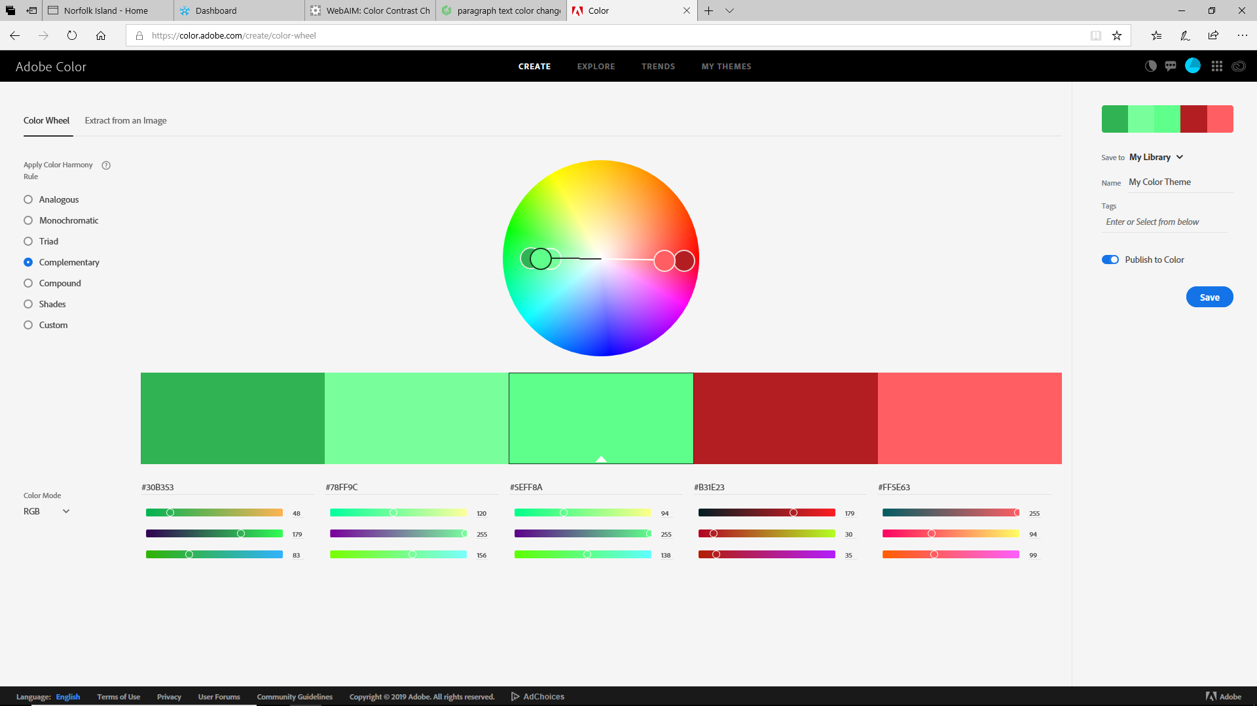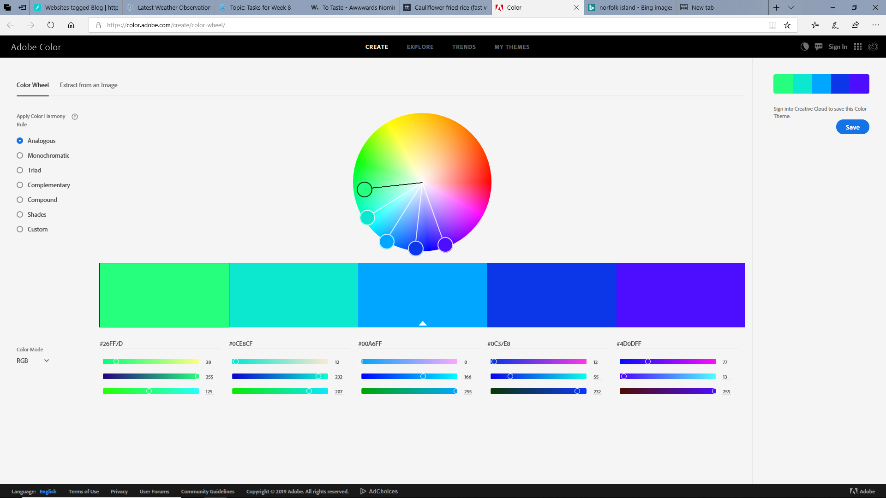

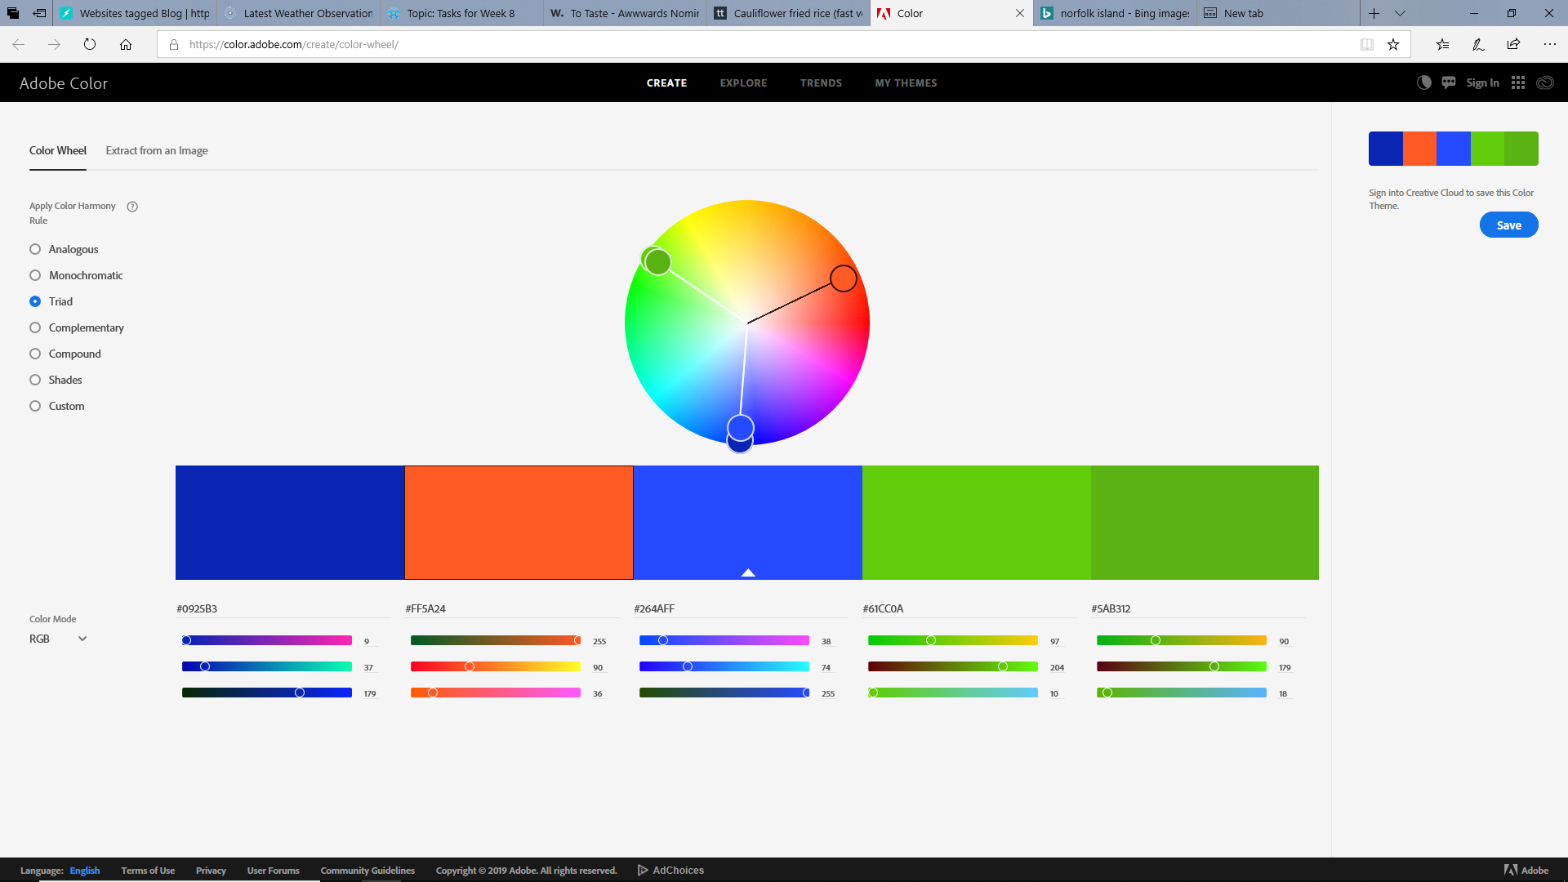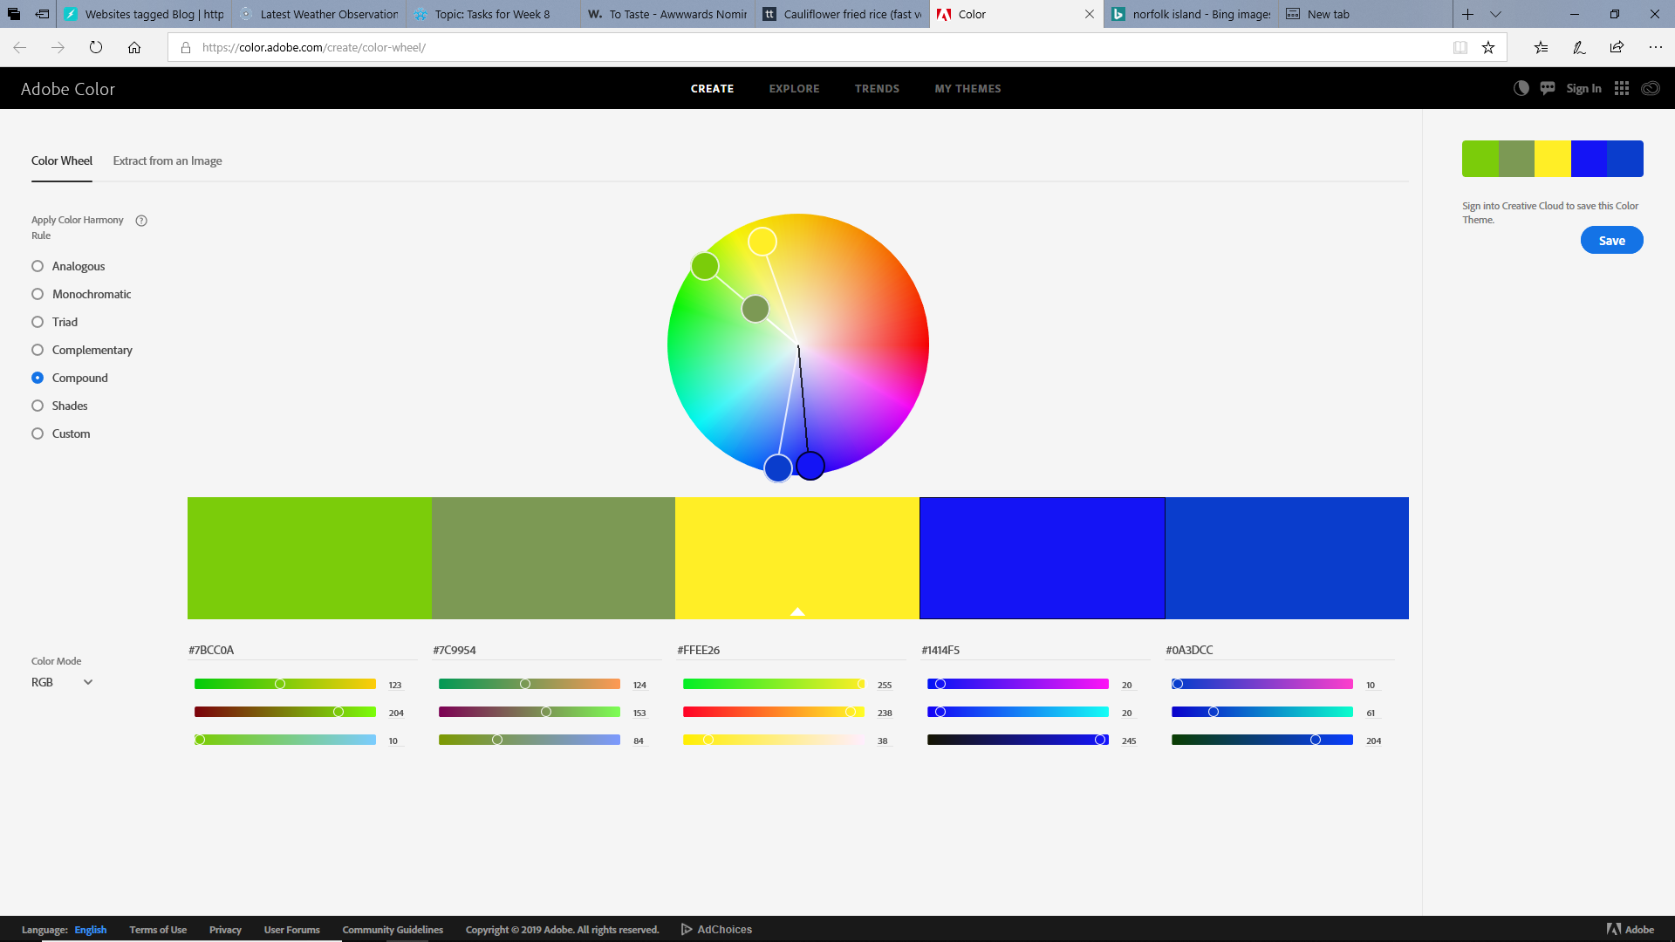

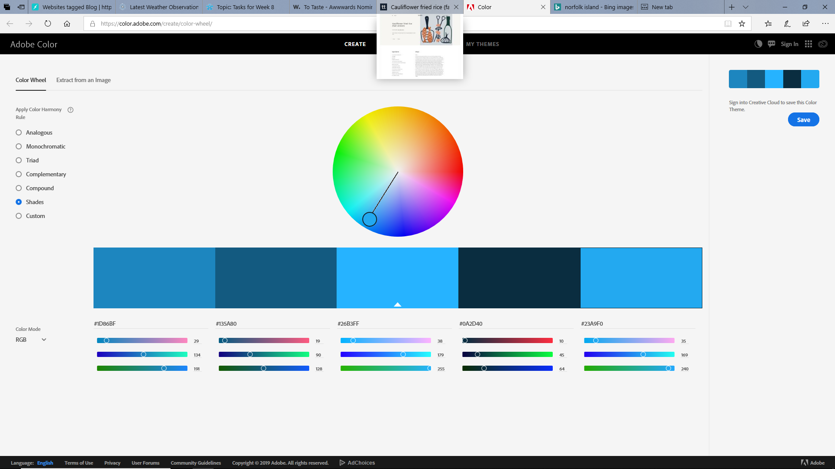

Having an idea that I wanted each section in the layout to be coloured different, I went to the colour wheel provided by w3 schools and used this to help me with selecting appropriate colours to be used for the elements and containers within each page, to be defined in the CSS stylesheet. I did consider and try all of the colour schemes seen in the screenshots shown here but eventually decided on the bottom one, which contains 5 shades of blue. This being case, due to accessibility issues faced later, I was forced to change some of the shades of the colours used slightly, so that the contrast ratio of 4.5:1 would be achieved.

### Fonts

Apart from this I also performed extensive research into things such as background gradients and also some different font-family options to be used, to not be more aesthetically pleasing, but also more accessible.

I decide to use a google font called “crimson text”, which can be found here; <https://fonts.google.com/specimen/Crimson+Text>

Although it is not a sans-serif font, it appeared to me, to be significantly easier to read than many of the standard fonts commonly used, especially when reading large paragraphs, like are found within my website.

Crimson font looks like this;

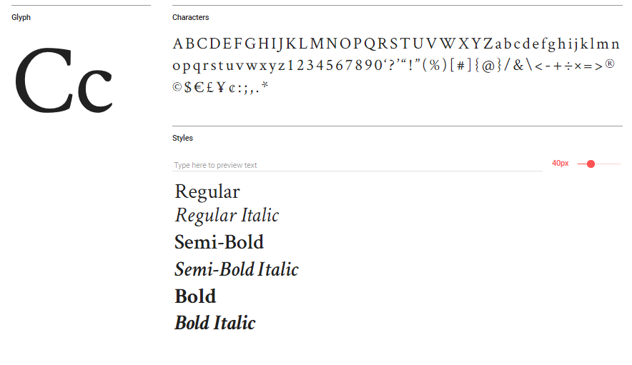

## Accessibility issues or usability issues

As is mentioned below in the accessibility audit, I encountered a few errors and warnings, most of which were regarding the use of headings. The first error was that an unordered list was being used in a span. The other was that the class was duplicated in one image, meaning the class was declared twice in one line. Other than this there were a few warnings, which mostly detailed that headings were required, where sections were being used. The other warning which I had received was that h1 headings were only to be used at the top of the page.

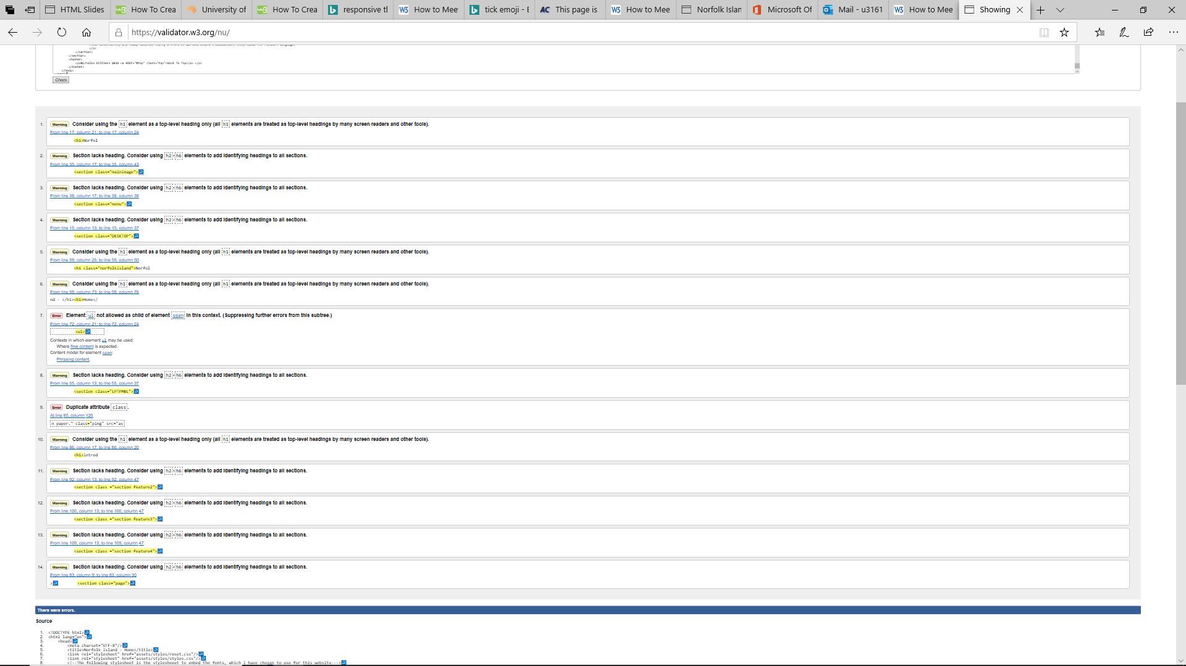

## How were they resolved?

To combat the issue of duplicated classes, I simply deleted all instances where classes were declared more than once. To eliminate the issue where an unordered list cannot be the child of a span container, I changed the semantic name of the span, so that it was now a section container. To fix the issues of sections not containing headings, I added headings to each section where headings were not used. This helps especially when using screen readers to locate content on the page more easily and without the addition of these headings, would prove difficult. Finally, unfortunately, due to the nature of the website it is not possible to suppress the warning that the h1 should only be used at the top of the website. Luckily, the h1 which this warning relates to is located at the top of the page and so does not present issues when trying to locate h1 elements, when using a screen reader to locate the top of the page.

The reviewed check now only returns one warning for each page. That is that the h1 should only be used at the top of the page. Because the h1 in question is at the top of the page, this can be disregarded.

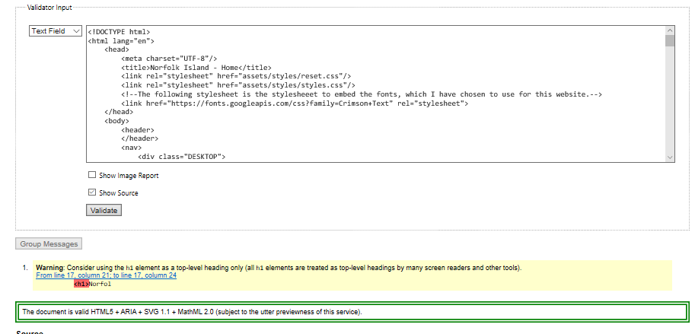

# Accessibility Audit

It has been determined in the course content and the assignment briefing that the website should meet the following criteria;

[1.1.1](https://www.w3.org/WAI/WCAG21/quickref/?versions=2.0#non-text-content) – Non-text Content - Provide text alternatives for non-text content

I have ensured that I have included alternate text for every single image which can be found in the site. Initially I had very non-descript alternate text, but it was suggested by Riley that I include more descriptive and meaningful descriptions in the alternate text, of between one to two sentences. This is especially important to accessibility as it can allow someone who may not be able to see the image at all, or in full detail, to understand what the image is without being able to see it. The images alternate text should use descriptive language, which allows the user to imagine or picture what the image might look like, in their mind. Based on this, I concur that the website I have created passes this standard. 

[1.3.1](https://www.w3.org/WAI/WCAG21/quickref/?versions=2.0#info-and-relationships) – Info and Relationships - Logical structure

This point relates to how well the meaning of non-text elements is represented by the elements surrounding them, for example, by using captions, headings, paragraphs or any other text element which can provide insight to the context of the element. The most common way this can be done is by using semantic HTML, wherein the name of the element describes its function, for example an <img> tag contains an image, and this can be determined using screen reader. I have attempted to ensure that there are no elements in my website do not conform to semantics. Based on this, I concur that the website I have created passes this standard.   
[1.3.2](https://www.w3.org/WAI/WCAG21/quickref/?versions=2.0#meaningful-sequence) – Meaningful Sequence - Present content in a meaningful order

The content of the website is presented in a standard and conventional way, with all text read left to right, and lines read top to bottom. There are no instances where the meaning changes based on where the element is positioned, no white spaced used for spacing, and does not use a layout which does not make sense when the view changes. Because the design passes all of these criteria, I am satisfied that the website I have created meets this criterion.   
[1.4.1](https://www.w3.org/WAI/WCAG21/quickref/?versions=2.0#use-of-color) – Use of Colour - Don’t use presentation that relies solely on colour

There are no instances in my website where a specific colour or tone is sued to convey meaning within the website and a contrast ratio of at least 4.5:1 has been used between all text and its container. This being the case I assess my website as passing this criterion.   
[1.4.2](https://www.w3.org/WAI/WCAG21/quickref/?versions=2.0#audio-control) – Audio Control - Don’t play audio automatically

There is no audio, whatsoever used in my website at all and so it is not possible for my website to fail the accessibility based on this.   
[2.1.1](https://www.w3.org/WAI/WCAG21/quickref/?versions=2.0#keyboard) – Keyboard - Accessible by keyboard only

The website is fully navigable via the keyboard only, and every page and section within the website can be accessed from every other page and section in the website using the keyboard. Initially, with my design, where two separate navigation menus are used, issues were presented. I have implemented a desktop navigation menu, which appears at the top of the page in the desktop view only. I have also implemented a mobile/tablet navigation menu, which only appears when the viewport is within these ranges. This being the case, it was possible to use both menus, by tabbing with the keyboard. This was because I had defined the menus to be “display: hidden;”, where it should have been “display: none;”. The difference between these two properties, is that with “hidden”, the menu still is in existence and so technically can be clicked, whereas when it is set to “none’ it does not exist and cannot be clicked. Changing this property allowed me to navigate the website with the keyboard, without repetition of menu link items. Initially, this criterion would not have been met, but due to the rectification of this issue, I am now satisfied that this criterion has been met.   
[2.1.2](https://www.w3.org/WAI/WCAG21/quickref/?versions=2.0#no-keyboard-trap) – No Keyboard Trap - Don’t trap keyboard users

By using the “Tab” key found on most standard QWERTY keyboards, the user is able to select links within the website. Once the user has focussed on a particular link, they can hit “enter’ on the keyboard to click that link. If the user pressed the “Tab” key more than once, the focus will move to the next available link. Once all of the links have been cycled through, if the user continues to press “Tab”, the focus will move to the controls of the user’s browser. This continues in this pattern indefinitely, until the user navigates to the desired link and so the user can never be trapped once the focus is on the last link on the page. For this reason, I am confident that the user cannot become trapped when only using a keyboard for navigation and so this criterion has been met. 

[2.3.1](https://www.w3.org/WAI/WCAG21/quickref/?versions=2.0#three-flashes-or-below-threshold) – Three Flashes or Below - No content flashes more than three times per second

As there are no instances of where content flashes within my website, there are also no instances of where there are more than three flashes and so this accessibility criteria have been met and satisfied.   
[2.4.2](https://www.w3.org/WAI/WCAG21/quickref/?versions=2.0#page-titled) – Page Titled - Use helpful and clear page titles

Each page found within my website has a title on the tab in the browser, at the very top of the page (in the header), and at the start of the page content. There are four pages named Home, Description, Locations and History. Home, the name suggests, is the home page of the website and provides an introduction as to what Norfolk Island is. Description is a page which describes Norfolk Island and Its surroundings. Locations describes all of the locations that can be found on Norfolk Island. History is a page which describes, in detail, the history of Norfolk Island. These names, used as page titles, give a clear meaning for what each page is related to or about, and so was assessed as passing the criteria.   
[2.4.3](https://www.w3.org/WAI/WCAG21/quickref/?versions=2.0#focus-order) – Focus Order - Logical order

This criterion is primarily concerned with the order in which content is placed and how that affects the meaning of it. An example might be in a recipe, where the steps or instructions are not in numerical order, which affects the success of the recipe. In the case of my website, I have ensured that the images which I have included are belonging to the paragraphs which they are contained within. Beside this, there are no other obvious sequences or order in which the content needs to be configured to maintain its meaning and so I have assessed this website as passing this criterion point.   
[2.4.4](https://www.w3.org/WAI/WCAG21/quickref/?versions=2.0#link-purpose-in-context) – Link Purpose (In Context) - Every link’s purpose is clear from its context

Much like with the title, each link must have a clear direction and purpose. This is so that when a user is trying to navigate to a specific part of the website, they are able to without have and can click on links predicting where the information or page that they need can be found. I have named all of the links in the website as the same name as the page that they are linking to. The only exception to this is the “Back to top” link found in the footer of each page, which returns the user to the top of the page, that they are currently on. I would suggest that, for these reasons the website passes on this point.   
[3.1.1](https://www.w3.org/WAI/WCAG21/quickref/?versions=2.0#language-of-page) – Language of Page - Page has a language assigned

This point is important, especially when a user is using a screen reader or translator. It allows the system that the user is using to identify the language in which the page is written, to be used to help navigate the site or translate the site. I have included ‘lang="en"’ in the opening HTML tag of each page for this reason. Because each page in the website contains this and so the language is declared as being English, this criterion is met. 

[4.1.1](https://www.w3.org/WAI/WCAG21/quickref/?versions=2.0#parsing) – Parsing - No major code errors

Initially the code in all 4 of my pages, failed, due to not validating for multiple errors and warnings. These errors were mainly regarding using h1 headings as anything other than top level headings and having sections with h1 headings instead of h2-h6 headings. Two other errors or warnings which were made apparent, were that unordered lists are not legally allowed to be child elements of a span and duplicate classes exist. These errors and warnings can be seen in the screenshots below.

The following image shows the errors and warnings for the home page.

.

This image shows the errors and warnings that were returned for the description page.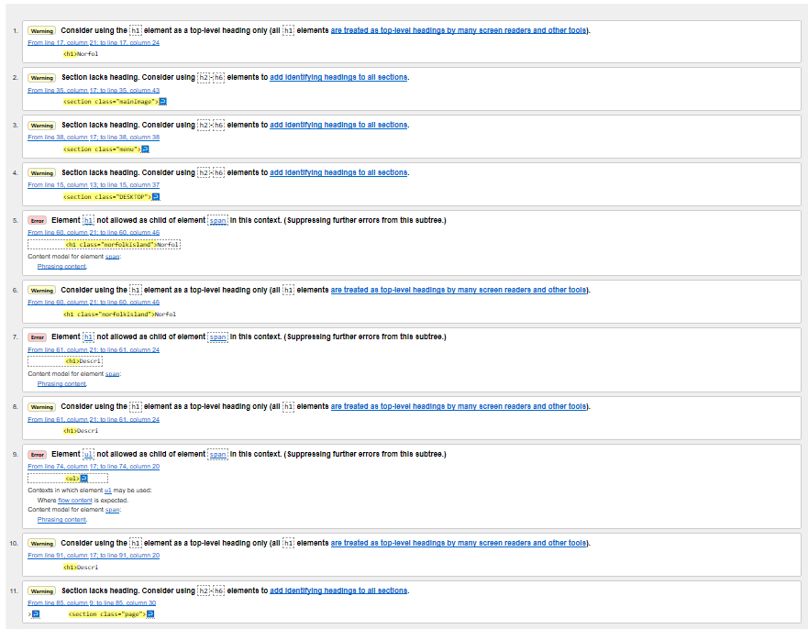The next image shows the errors and warnings that were returned for the History page.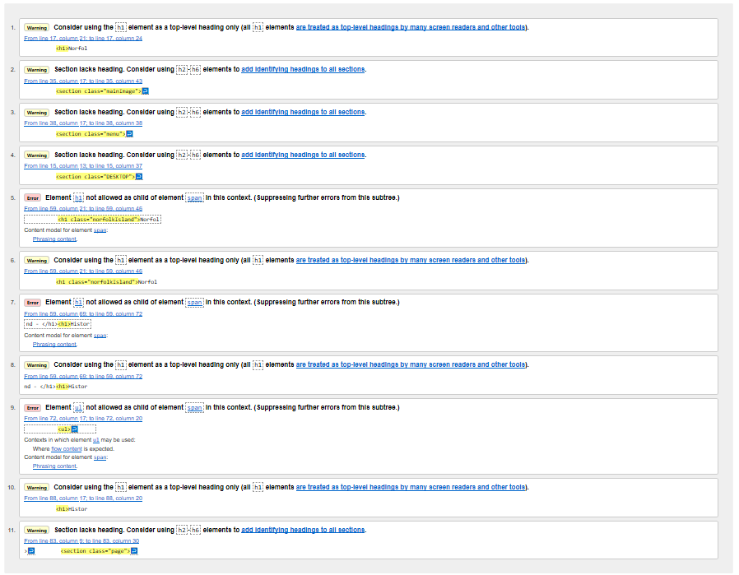

Finally, the image below shows the errors and warnings returned for the Locations page.

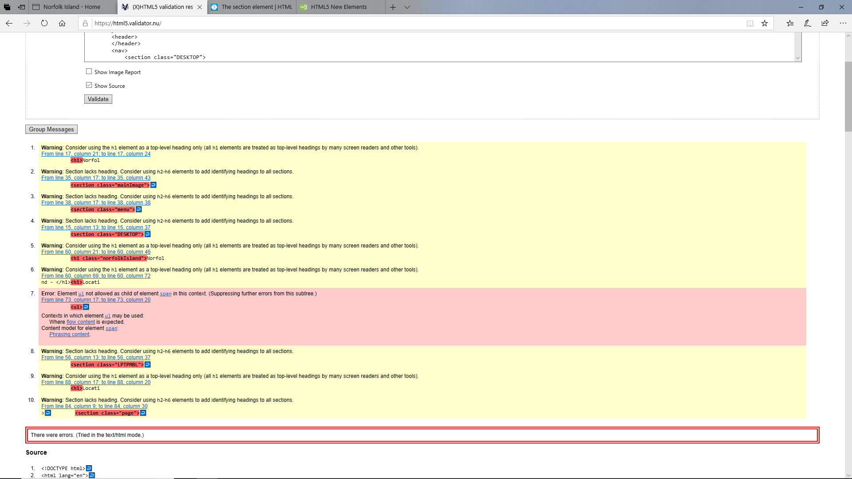

After rectifying all errors in the HTML, my website has validated according to HTML semantic standards. This being the case, there are still a few warnings. These warnings exist because I have use sections which do no not contain headings, and 1 warns against using a h1, unless it is for a top element, which it is. It is important that the h1 elements are reserved for the top of the page because some screen readers use the h1 element to locate the top of the page.

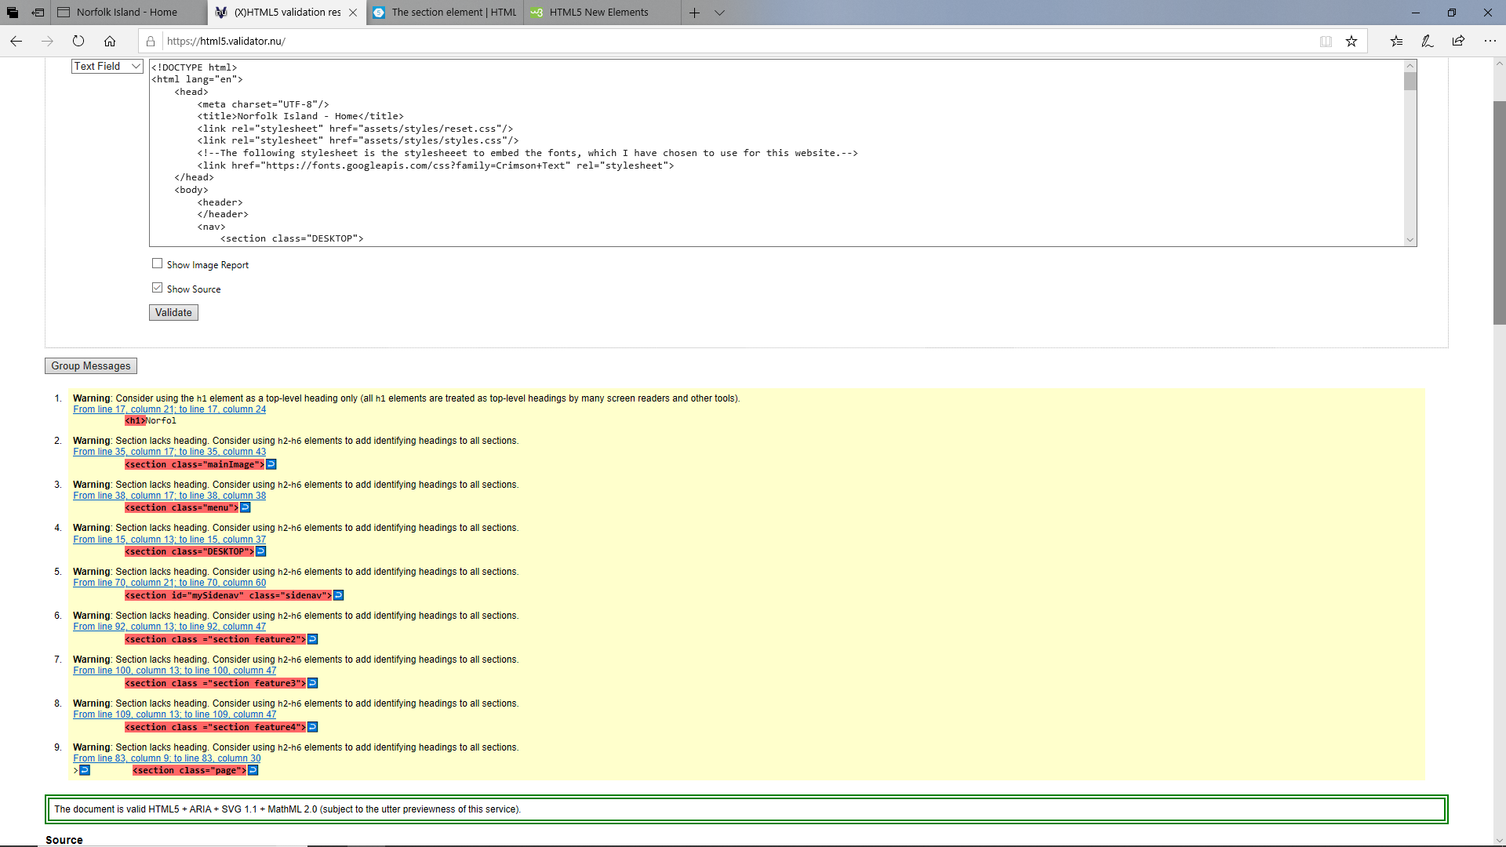

Although, when first semantically tested, the website did not meet requirements outlined in this part of the accessibility audit, I am confident that, after rectifying these errors that the website sufficiently meets these requirements. 

Overall, the website has proven viable, and that it can adhere to the WCAG 2.0 AA standards set out for the requirements of this assignment and I therefore confirm that this website passes these requirements.

On top of manually checking against these standards, I have checked my website using the Web Accessibility Checker, found at <https://achecker.ca/checker/index.php> .

## Importance and context of accessibility

The world wide web (W3) is intended to be used by all people regardless of ability, age, location, language, hardware, etc. Accessibility is primarily focussed on providing this to people who from varying levels of sight, hearing, movement, cognitive ability, or any other impairment. Having a disability has a large impact on the ability of someone to use a website effectively, and badly designed web sites can create barriers which exclude people from minorities, or with disabilities from using the web. It is vital that developers and organisations create high-quality websites, which do not exclude or prevent anyone from using the site.

Web accessibility can be defined as being websites, tools, and different technologies, which are designed with the intention of being used by people with disabilities in a way that it easier than when using a website that is not accessible. Web accessibility enables people with disabilities to perceive, navigate, interact and understand the web and internet. On top of this people with disabilities should not only be able to access and use the web, but also make contributions to the web. The types of disabilities which are usually considered when developing accessible websites are auditory, cognitive, neurological, physical, speech and visual impairments or deficits. Some common examples of web accessibility, for people who don’t have disabilities might include;

* Elderly persons with changing abilities, attributed to old age.
* People with non-permanent disabilities, such as someone with a broken arm.
* A person in an environment where they cannot hear the audio being played, because it is too noisy where they are.
* People who may have a slow internet connection

The web and internet are becomingly increasingly relied upon in society and so it is important that as we grow more dependent on the web, that people who have disabilities do not become even further disadvantaged by their disability, instead we must strive to make websites and the internet accessible and usable by these people.

## Summary of main accessibility issues within the site

As explained in the accessibility audit, the main issues which I had encountered when performing accessibility testing were the contrast of the text used in paragraphs to their container’s backgrounds, the multiple duplicate menu links that could be used when navigating using a keyboard only and the validation errors which were made apparent when I validate the pages during the accessibility audit. These three issues together would have made it extremely hard, confusing and frustrating for a user with a disability to navigate or use the page.

## Explanation of main accessibility issues

These issues have the following effects, if not rectified;

* Low contrast of text on section backgrounds;

If the contrast of the text was not checked, this may have presented issues for users who have optical issues or vision impairment. To avoid issues related to low contrast I have checked each section and its text to against the contrast checker found at <https://webaim.org/resources/contrastchecker/>.

On top of this I have also used the “”no Coffee” plug-in for google chrome which allows the user to simulate optical impairments and disabilities to ensure that the site is usable to persons who possess these.

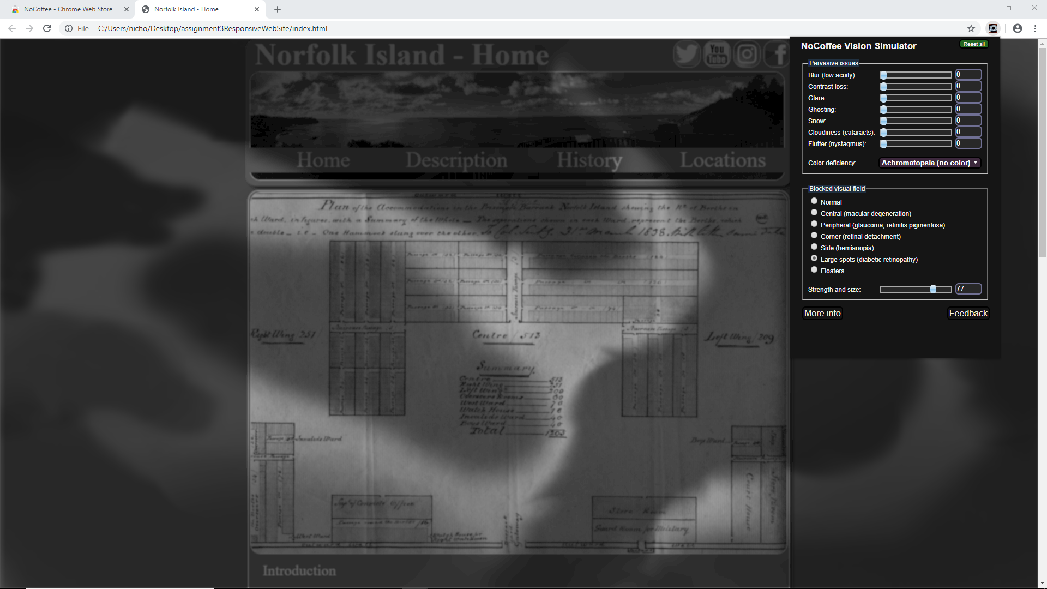

* Duplicate menu links when using keyboard only, for navigation;

Due to two separate navigation menus being used, I have configured my media queries so that only one is displayed at a time. This being the case, both were originally still navigable when using keyboard only. This is because I had set the desktop menu to be hidden when the laptop/mobile menu is shown. I should have however, set it to be “display: none;” rather than “display: hidden;” in the CSS, so that instead of just not being visible, the menu would not be created and therefore could not be click. If I did not rectify this issue, this could have been very confusing for a user who is trying to navigate the site using only the keyboard. If the user was using a screen reader, this also would prove problematic, as there would be two elements with the exact same names, but in different locations, making navigation very confusing and hence not very accessible at all.

* Validation errors when checked during accessibility audit;

Because I had not placed headings in some of the sections, validation errors were returned when validating as part of the accessibility audit. Apart from returning errors, not having headings provided for content makes navigation hard for users who are vision impaired and may be relying on screen readers to find a particular place in the page, or piece of information. This would prove impossible, if there were no headings in place throughout the page and the screen reader would have to instead perform a linear search of the entire page to locate what the user was searching for.

# Summary

I have thoroughly enjoyed partaking in this course. Although I am enrolled in a Bachelor of Information Technology degree, this unit was actually an elective for me. I enrolled in this unit because I enjoyed designed things and solving problems in new and different ways. Although I have already, throughout the course of my degree, completed some units which involve web design, this particular one has taught me a lot of things I did not already know. I enjoyed the structure and the progressive nature of the unit and how each module built on the last. In this assignment in particular I have learnt new CSS techniques and delved deeper into responsive design than I have previously in other units. I feel as though I have inherited a lot of knowledge and skills that I may not have thought of as being part of the web design process. I learnt the importance of planning the layout and transitions of the website, drawing them on paper, drawing them digitally and finally building the website. I have built an increased appreciation for the amount of creative thought, but also logical paternal thought that is associated with creating a website which is responsive and accessible. I have now a greater understanding of the need for accessibility and how small changes to a web site may not even be notice by an ordinary user, but to a person experiencing disability may mean the difference between being able to use the website or not. I now have a better understanding of assistive technologies which can be used to help a person with a disability use a website.